
Register one of 3 ways:
Visit www.active.com.
Visit www.lvfiestarun.com to download form and mail it in.
Take a picture of the image below with your smartphone and follow the link.

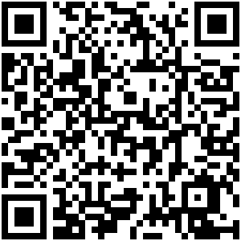

Call 505-652-0208 for inquiries


